# CAA Greece National Chapter Information and Report

**National Chapter*: Greece**

**Submitted by*: Emeri Farinetti**

**Date Submitted*: 15/03/2024**

*Please complete the following information about your national chapter. The information in fields with asterisks (*) will be published on the CAA International website. All other information will not be publicly shared. Reports should be emailed to CAA’s Secretary at* [*secretary@caa-international.org*](mailto:secretary@caa-international.org)*.*

## Chapter Organisational Details

### Chapter Leadership

**Term Dates for the Current Steering Committee:**

|  |  |  |
| --- | --- | --- |
| **Name\*** | **Chapter Position\*** | **Email Address** |
| Emeri Farinetti | Chair | emeri.farinetti@uniroma3.it |
| Theodora Moutsiou | Deputy Chair | tmouts01@ucy.ac.cy |
| Anestis Koutsoudis | Secretary | akoutsou@athenarc.gr |
| N. Pinar Özgüner Gülhan | Treasurer | pinar.ozguner@gmail.com |
| Areti Damala | Publication Officer | areti.damala@gmail.com |
| Cristina Manzetti | Social Media, Communications and Outreach | manzetti.maria-cristina@ucy.ac.cy |

*All National Chapters must have at least three officers according to CAA’s Constitution. Any time there is a change in your chapter’s leadership, please notify the CAA Secretary.*

**CAA Steering Committee Representative*: Emeri Farinetti**

This is often the chair, but any member of the chapter’s leadership can be designated as the Steering Committee representative. However, the Steering Committee representative **must be a member of CAA International** while serving in this capacity**.**

## Chapter Membership

**Total Number of Current Members:**

**If you have different categories membership categories for Full Members, Students, and/or Low Income Members, please provide the numbers of members at each level:**

|  |  |
| --- | --- |
| **Membership Level** | **Number of Members** |
| **Full Members** | 187 |
|  |  |
|  |  |
|  |  |
|  |  |

## Chapter Contact Information

**Chapter Website*: https://gr.caa-international.org/**

**Chapter Social Media Channel(s) (optional):**

|  |  |
| --- | --- |
| **Platform\*** | **Handle\*** |
| Twitter (X) | https://mobile.twitter.com/caa_gr |
| Facebook | https://www.facebook.com/CAAGreece/ |
| Instagram | - |
| LinkedIn | - |
| YouTube | - |
|  |  |
|  |  |
|  |  |

**General Contact Email for the Chapter*:** [**info@gr.caa-international.org**](mailto:info@gr.caa-international.org)

*If you do not have a general chapter email address, please contact the secretary to have one created. The email can be set up as a separate inbox or as a forwarding account.*

## Chapter Description

**Brief Description of Your Chapter*:**

*Please provide a few sentences or a paragraph describing your chapter, such as the kinds of activities you organise, when it was founded, who should join, etc. These descriptions should not include specific details about upcoming activities as they are meant to be “evergreen” and to drive traffic to your chapter’s website to learn more.*

The Greek chapter of the international non-profit organization “Computer Applications and Quantitative Methods in Archaeology» (CAA-GR) was established in 2012. Members of CAA-GR are scientists from the fields of archeology, social sciences, life sciences, arts, mathematics, information technology, engineers and scientists in all fields of cultural heritage.

The objectives of the organization are:

1. to encourage the communication between these disciplines,
2. to provide an overview of current research in the field of computer applications and quantitative methods in archeology,
3. to give rise to debate and future progress in the area of research,
4. to offer guidance and support in the form of seminars and / or workshops
5. to publish the results of research reported in scientific meetings organized by the CAA-GR,
6. to support relevant research in these fields in the region of the Eastern Mediterranean.

CAA-GR brings together a range of scholars, specialists and experts in the fields of archaeology, history, cultural heritage, digital scholarship, GIS, mathematics, semantic web and informatics who work in the Eastern Mediterranean region, encompassing Greece, Cyprus, Italy and Turkey. The aim of the Greek National Chapter of the CAA is to encourage communication among scholars of the aforementioned fields conducting research in the Eastern Mediterranean and facilitate interdisciplinary cooperation. CAA-GR also aims to provide a platform for scientists at all levels to present their work and current research in the field, to stimulate discussion and offer guidance and support in the form of seminars and/or workshops, especially for young scientists in order to strengthen interdisciplinary collaboration in the Eastern Mediterranean.

**Translated Description in Your Chapter’s Language(s)*:**

*If you would like to include the same description in your chapter’s language(s) as well, please provide the translation.*

Tο Ελληνικό παράρτημα του διεθνούς μη κερδοσκοπικού οργανισμού «Εφαρμογές Πληροφορικής και Ποσοτικές Μέθοδοι στην Αρχαιολογία» (CAA-GR) ιδρύθηκε το 2012. Μέλη του CAA-GR είναι επιστήμονες από τον χώρο της αρχαιολογίας, των κοινωνικών επιστημών, των βιοεπιστημών, των τεχνών, των μαθηματικών, της πληροφορικής, μηχανικοί  και ειδικοί επιστήμονες σε όλους τους  τομείς της πολιτιστικής κληρονομιάς.

Οι στόχοι του οργανισμού είναι οι εξής:

1. να ενθαρρύνει την επικοινωνία μεταξύ των παραπάνω επιστημονικών κλάδων,
2. να προσφέρει μια ανασκόπηση της σύγχρονης έρευνας στον τομέα των εφαρμογών πληροφορικής και ποσοτικών μεθόδων στην αρχαιολογία,
3. να δώσει έναυσμα για διάλογο και μελλοντική πρόοδο στο σχετικό τομέα έρευνας,
4. να προσφέρει καθοδήγηση και υποστήριξη υπό μορφή σεμιναρίων ή / και εργαστηρίων,
5. να δημοσιεύσει τα αποτελέσματα έρευνας που ανακοινώνονται στις επιστημονικές συναντήσεις που οργανώνονται από το CAA GR,
6. να υποστηρίζει σχετική έρευνα στους παραπάνω τομείς στην ευρύτερη περιοχή της Ανατολικής Μεσογείου.

Το CAA-GR συγκεντρώνει μια σειρά μελετητών και ειδικών επιστημόνων στους τομείς της αρχαιολογίας, της ιστορίας, της πολιτιστικής κληρονομιάς, των εφαρμογών GIS, των μαθηματικών, και της πληροφορικής που εργάζονται στην περιοχή της Ανατολικής Μεσογείου, περιλαμβανομένης της Ελλάδας, της Κύπρου, της Ιταλίας και της Τουρκίας. Στόχος του Ελληνικού Παραρτήματος CAA-GR είναι να ενθαρρύνει την επικοινωνία μεταξύ επιστημόνων των προαναφερθέντων πεδίων που διεξάγουν έρευνα στην Ανατολική Μεσόγειο και να διευκολύνει τη διεπιστημονική συνεργασία. Το CAA-GR στοχεύει επίσης να παρέχει μια πλατφόρμα σε επιστήμονες όλων των επιπέδων ώστε να παρουσιάσουν το έργο τους , να προωθήσουν την επικοινωνία μεταξύ μελετητών και να προσφέρουν καθοδήγηση και υποστήριξη με τη μορφή σεμιναρίων ή/και εργαστηρίων, ειδικά για νέους επιστήμονες με στόχο την ενίσχυση της διεπιστημονικής συνεργασίας στην Ανατολική Μεσόγειο.

# Report for the CAA National Chapter of Greece

**Reporting Period*: April 2024 – April 2025**

**Submitted by*: Emeri Farinetti**

**Date Submitted*: 5/05/2025**

**Update on the National Chapter Activities:\***

**CAA-GR Session in EAA 2024**

CAA-GR organised a session at the European Association of Archaeologists (EAA) Annual Meeting held in Rome, Italy, between 28-31 August 2024. The session was entitled *“Current Status and the Future of Digital Archaeology in the Eastern Mediterranean” (Session #818)* and it aimed to discuss:

**Session: #818**

Conference Theme:

*2. Archaeological Sciences, Humanities and the Digital era: Bridging the Gaps*

Session format:

*Regular session*

Title:

*Current Status and the Future of Digital Archaeology in the Eastern Mediterranean*

Content:

*The Greek Chapter of the Computer Applications & Quantitative Methods in Archaeology (CAA-GR), which involves a wider research community from the Eastern Mediterranean area, invites scholars, researchers, academics, and professionals to explore the current and future state of digital archaeology in the Eastern Mediterranean.*

*Speakers and participants will have the opportunity to exchange knowledge and experiences on digital archaeology in the Eastern Mediterranean and will envision future directions. A strong focal point in the discussion will be on how the digital practice can cross boundaries and facilitate international collaboration. The intention is to establish a cross-border collegial environment where scholars share their experiences, highlight problems and offer potential solutions, knowledge transfer and know-how.*

*Participants from Greece, Cyprus, Turkey, and neighboring regions will share experiences and discuss digital scholarship levels in educational institutes, challenges in adopting curricula, managerial issues, and resource allocation strategies.*

*Colleagues from foreign archaeological missions will highlight their experiences managing digital projects in the Eastern Mediterranean, addressing integration challenges and unforeseen issues.*

*Presentations by scholars from the state sector will delve into the impact of digital transformation on archaeological projects, focusing on national policies, project evaluation, and the adoption/rejection of digital tools by archaeological services.*

*Ethical and legal concerns, surrounding digital archaeology in the Eastern Mediterranean including data creation and ownership, cultural heritage preservation, and responsible data-sharing practices, will be addressed.*

*The discussion extends to how digital archaeology projects engage the public, and promote cultural heritage preservation, by means of virtual exhibits, interactive educational resources, and community involvement in digital initiatives.*

*Please submit your proposals for presentations, papers, or case studies that align with the themes outlined above. Your insights and experiences will contribute to a robust discussion and the advancement of digital archaeology in this culturally rich and historically significant region.*

Keywords:

*Digital archaeology, Eastern Mediterranean, Cross-border collaboration, Knowledge exchange, Digital policies, Future directions*

Organisers:

*Dorina Moullou (Greece), Emeri Farinetti (Italy), Theodora Moutsiou (Cyprus), Nimet Pinar Ozguner Gulhan (Poland), Lukasz Miszk (Poland)*

-----The Session was formally associated with CAA international. The first 4 organisers were members of the CAA-gr committee at that time-----

Nine talks have been accepted in the session; see relevant list below:

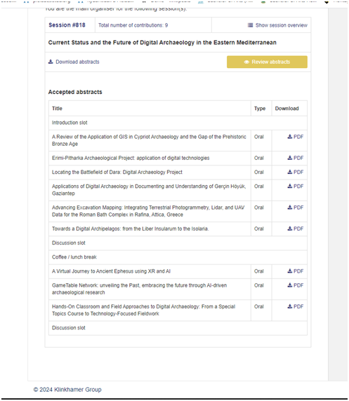

**CAA-GR Conference 2024**

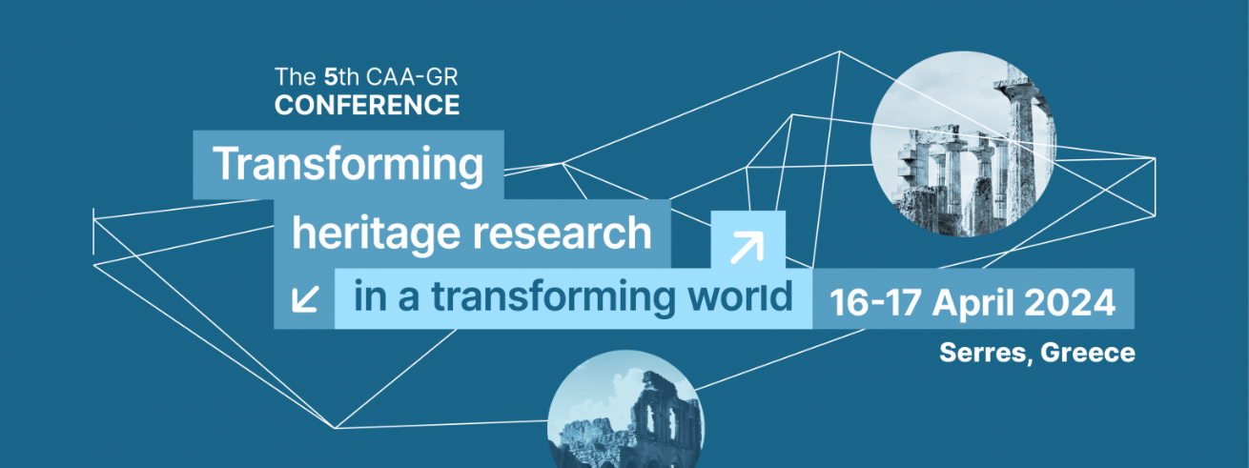In addition, the 5th CAA-GR Conference took place in spring 2024 in Serres, Greece, between 16-17th April. The title of the 2024 conference is *“Transforming heritage research in a transforming world”*. More than 90 participants registered.

*The world we live in is marked by challenging and often intimidating changes, as well as significant opportunities for growth. Throughout history, change has been an inevitable aspect of every era. For example, climate change is widely recognized as one of the most pressing global challenges of our time, with far-reaching impacts on the environment, societies, and economies worldwide, posing a severe threat to cultural heritage. These changes are transforming our world, threatening food security, human health, and social stability. At the same time, the world is rapidly moving towards an era of artificial intelligence (AI). While AI has the potential to revolutionise industries, improve efficiency, and create new opportunities, it also poses significant challenges for society, like the impact on the workforce, the ethical implications of AI, the perpetuation and even amplification of social and economic biases, the questions about accountability and responsibility, the safety and security from weaponized AI.*

*Digital technologies are changing the way we live, work, and communicate, while climate change and globalisation are transforming our social, economic, and environmental systems. In this context, cultural heritage has an essential role in shaping this transforming society. Cultural heritage can provide a sense of identity, continuity, and community and can help to preserve history and encourage intercultural understanding. Moreover, cultural heritage institutions can leverage digital technologies to enhance the accessibility and visibility of their collections, engage with diverse audiences, and promote cultural exchange. However, cultural heritage faces new challenges in this transforming world, such as the need to address climate change and its impact on heritage sites, the risks associated with globalisation, and the ethical implications of digital technologies. Therefore, cultural heritage must actively engage with these challenges to ensure its relevance and sustainability in a rapidly changing world. This requires cross-disciplinary/sectoral/border collaborations, as well as a commitment to preserving and promoting cultural diversity and heritage for future generations. It is a time to critically analyse the relationship between cultural heritage and the effects of the coming changes, whether economic, social, demographic, technological, cultural, or a complex combination of various forces. Considering the rapid pace at which dynamic influences shape change, cultural heritage has a crucial role in this context.*

Organising Committee

Stella Sylaiou, International Hellenic University, Serres, Greece

George Pavlidis, Athena Research Centre, Xanthi, Greece

The programme of the conference was as follows:

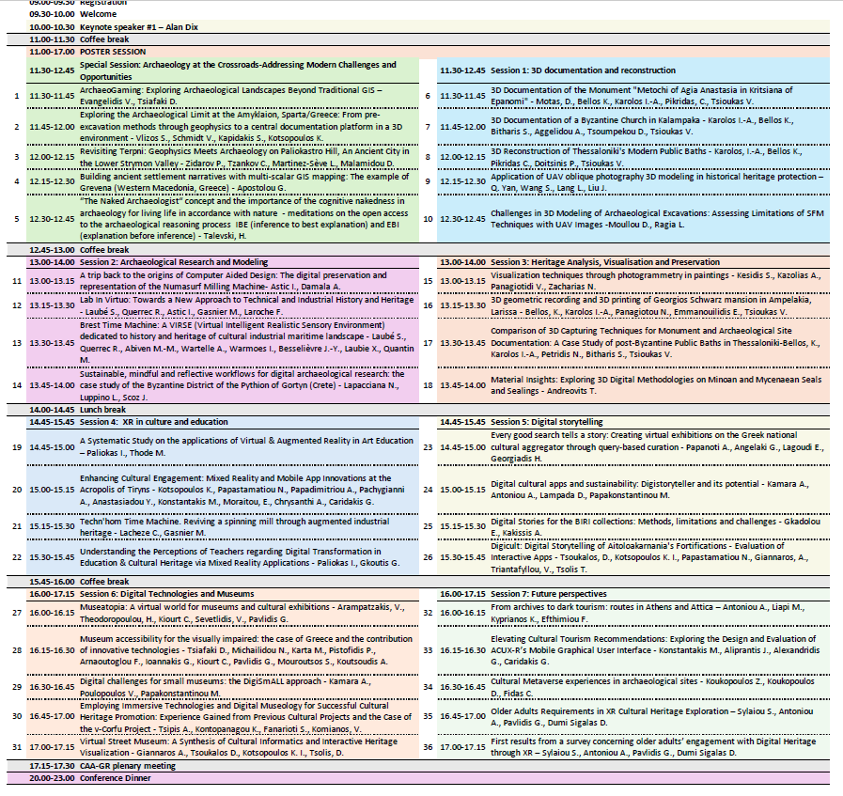

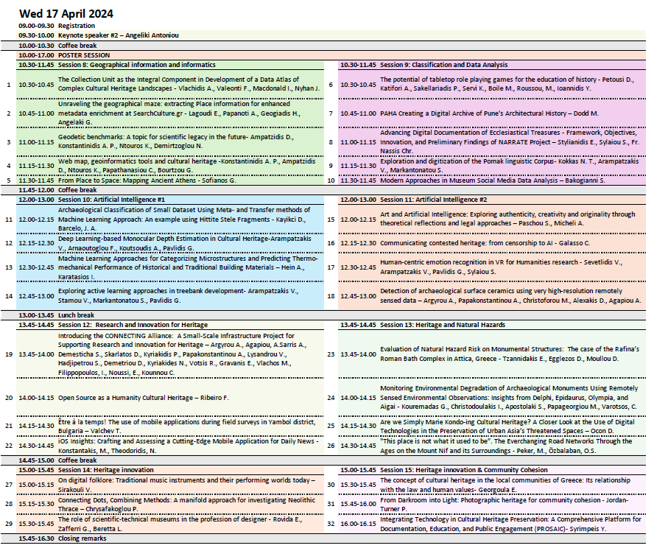

**CAA-GR Session at CAA International Athens 2025**

A session proposal was submitted and successfully accepted in the programme of the CAA International 2025to be held in Athens, Greece, 5-9 August 2025. The session is entitled *“Digitally Enabled Archeological Practice, Communication and Research: Critical reflections on evaluation and impact assessment” (Session #45)*. The number of papers accepted was set at 9. The session abstract is here below:

***Digitally Enabled Archeological Practice, Communication and Research: Critical reflections on evaluation and impact assessment***

Chairs: Emeri Farinetti, Theodora Moutsiou, Anestis Koutsoudis, Areti Damala

*Evaluation plays a crucial role both for cultural heritage (CH), museum and heritage studies and information technology (IT) scientists, as well as for various end users, in the context of tools, pipelines, solutions, and approaches focused on CH tasks.In their formal evaluation of public archaeology, Ellenberger and Richardson (2018) emphasize the importance of evaluating and assessing public archaeology projects as a means to promote and disseminate impactful research (Moullou et al 2023), despite this area being underrepresented in academic literature (Ellenberger & Richardson 2018). However, the need to evaluate a diverse range of methodologies is not limited to public archaeology. Evaluation plays a crucial role both for cultural heritage (CH), museum and heritage studies and information technology (IT) scientists, as well as for various end users, in the context of tools, pipelines, solutions, and approaches focused on CH tasks. Finally, evaluation is capital for meaningfully engaging with various stakeholders, target groups and audiences, increasingly encompassing collaborative and citizen science approaches. (Rimvydas et al 2018).*

*The recent EU Commission project calls and initiatives around a new European Collaborative Cloud for Cultural Heritage (ECCCH) underline that archaeological research fieldwork “produce large amounts of different kinds of data, such as survey documentation and documents presenting, narrating and interpreting the findings, photographic data, 3D models, drawings, maps and geographic information system data” (EU Commission, 2024). Furthermore, managing archaeological data requires expertise in interdisciplinary fields such as computer science and archaeology, alongside digital methodologies like database design, Geographic Information Systems (GIS) and spatial analysis, 3D reality modeling, digital twins. Within this new ECCCH it is acknowledged that data sets produced in later stages in later stages of archaeological and cultural heritage related works, become assets for cultural heritage institutions including museums, online archives, applications and plethora of new mediums.*

*Over the past decades, archaeological research has increasingly adopted these digital technologies to assist in excavations and field research, leading to the generation of vast amounts of archival data and documentation data (Psarros et al. 2022). As Opgenhaffen (2022) rightly points out, digital technologies are believed to enhance equal access to data and broaden inclusivity beyond archaeologists. However, the challenge of identifying and effectively reaching these broader audiences remains unresolved (Opgenhaffen 2022).*

*Thus, for CH and IT scientists, evaluation, quality control and assessment practices ensure that methodologies and technological solutions are effective, efficient, and scalable, while also providing data-driven insights for continuous improvement, providing opportunities for engagement with diverse audiences (Watrall 2019).*

*Evaluation can help verify the accuracy, reliability, and innovation of the tools and approaches used in documenting, preserving, restoring, and disseminating cultural heritage. From a researcher, end user as well as public engagement' perspective, undertaking qualitative, quantitative and mixed methods' evaluation is equally important, for assessing the usability, accessibility, scalability, sustainability, subjective and objective efficiency of the various tools, methodologies and datasets used and generated. Furthermore, engaging the public and gathering feedback ensures that the solutions not only meet scientific and technical standards but also resonate with and serve the needs and expectations of diverse cultural heritage communities (Ciolfi et al. 2018) and audiences, thereby enhancing the broader societal value of cultural heritage preservation efforts and magnifying their impact (Hugget 2015).*

*To this end, the Greek Chapter of the Computer Applications & Quantitative Methods in Archaeology (CAA-GR), which involves a wide scientific community from the Eastern Mediterranean region, proposes an insightful conference session dedicated to the convergence of humanities, archaeology, and technology, emphasizing the evaluation of projects, tools, pipelines, processes, methods, frameworks, approaches and user experiences related to the documentation, preservation, restoration, and dissemination of archaeological cultural heritage.*

*This session will explore both objective and subjective evaluation strategies from the perspectives of scientists and the public, including various types of stakeholders. In particular, we seek reflective (Huggett 2015) contributions on the evaluation and impact assessment around archaeological research, practice, documentation, dissemination using the digital for diverse end users, audiences and stakeholders (Walcek et al 2016).*

*We therefore welcome works on:*

* *The evaluation of archeological practices, from excavation, to documentation, visualisation, 3D reconstruction, restoration, cross-linking and dissemination*
* *Reflexive procedures around everyday archaeological practice using the digital, in the field and during data analysis, documentation and interpretation processes (at any stage of the life-cycle of a project)*
* *Applications and digital products related to the visualization and dissemination and public engagement on both tangible and intangible Cultural Heritage*
* *Public engagement and community practices and their short, medium and long term impact*
* *Stakeholders, end users and community (public) engagement practices and their impact*
* *Reflections on the meaning and method of evaluation and its impact on the epistemological, ethical and practical goals of Archaeology*

*Discussions will highlight the significance of these evaluation procedures in ensuring the effectiveness and relevance of preservation efforts, fostering a comprehensive understanding of cultural heritage, and enhancing public engagement and education.*

## Updates for CAA’s ESC

**Is there any information about your chapter or its activities that you would like to tell CAA’s Executive Steering Committee? This information will only be shared with the CAA’s officers and will not be made publicly available.**

Elections for the regular renewal of the board were concluded by June 2024. The members of the new board are mentioned above.

The website has been updated to the new CAA format in every section.