# CAA National Chapter Information and Report

**National Chapter*: CAA-GR (Greek Chapter)**

**Submitted by*: Emeri Farinetti**

**Date Submitted*: 31/03/2023**

*Please complete the following information about your national chapter. The information in fields with asterisks (*) will be published on the CAA International website. All other information will not be publicly shared. Reports should be emailed to CAA’s Secretary at* [*secretary@caa-international.org*](mailto:secretary@caa-international.org)*.*

## Chapter Organisational Details

### Chapter Leadership

**Term Dates for the Current Steering Committee:**

|  |  |  |
| --- | --- | --- |
| **Name\*** | **Chapter Position\*** | **Email Address** |
| Emeri Farinetti | Chair | emeri.farinetti@uniroma3.it |
| George Pavlidis | Deputy Chair | gpavlid@gmail.com |
| Theodora Moutsiou | Secretary | tmouts01@ucy.ac.cy |
| N. Pinar Özgüner Gülhan | Treasurer | pinar.ozguner@gmail.com |
| Dorina Moullou | Publication Officer | thmoullou@hotmail.com |
| Stella Sylaiou | Social Media, Communications and Outreach | sylaiou@gmail.com |

*All National Chapters must have at least three officers according to CAA’s Constitution. Any time there is a change in your chapter’s leadership, please notify the CAA Secretary.*

**Representative who will serve on the CAA Steering Committee*: Emeri Farinetti**

This is often the chair, but any member of the chapter’s leadership can be designated as the Steering Committee representative. However, the Steering Committee representative **must be a member of CAA International** while serving in this capacity**.**

## Chapter Membership

**Total Number of Current Members:**

**If you have different categories membership categories for Full Members, Students, and/or Low Income Members, please provide the numbers of members at each level:**

|  |  |
| --- | --- |
| **Membership Level** | **Number of Members** |
| **Full members** | **171** |
|  |  |
|  |  |
|  |  |
|  |  |

## Chapter Contact Information

**Chapter Website*: https://gr.caa-international.org/**

**Chapter Social Media Channel(s) (optional):**

|  |  |
| --- | --- |
| **Platform\*** | **Handle\*** |
| Twitter | https://mobile.twitter.com/caa_gr |
| Facebook | https://www.facebook.com/CAAGreece/ |
| Instagram | - |
| LinkedIn | - |
|  |  |
|  |  |
|  |  |

**General Contact Email for the Chapter*:** [**info@gr.caa-international.org**](mailto:info@gr.caa-international.org)

*If you do not have a general chapter email address, please contact the secretary to have one created. The email can be set up as a separate inbox or as a forwarding account.*

## Chapter Description

**Brief Description of Your Chapter*:**

*Please provide a few sentences or a paragraph describing your chapter, such as the kinds of activities you organise, when it was founded, who should join, etc. These descriptions should not include specific details about upcoming activities as they are meant to be “evergreen” and to drive traffic to your chapter’s website to learn more.*

The Greek chapter of the international non-profit organization “Computer Applications and Quantitative Methods in Archaeology» (CAA-GR) was established in 2012. Members of CAA-GR are scientists from the fields of archeology, social sciences, life sciences, arts, mathematics, information technology, engineers and scientists in all fields of cultural heritage.

The objectives of the organization are:

1. to encourage the communication between these disciplines,
2. to provide an overview of current research in the field of computer applications and quantitative methods in archeology,
3. to give rise to debate and future progress in the area of research,
4. to offer guidance and support in the form of seminars and / or workshops
5. to publish the results of research reported in scientific meetings organized by the CAA-GR,
6. to support relevant research in these fields in the region of the Eastern Mediterranean.

CAA-GR brings together a range of scholars, specialists and experts in the fields of archaeology, history, cultural heritage, digital scholarship, GIS, mathematics, semantic web and informatics who work in the Eastern Mediterranean region, encompassing Greece, Cyprus, Italy and Turkey. The aim of the Greek National Chapter of the CAA is to encourage communication among scholars of the aforementioned fields conducting research in the Eastern Mediterranean and facilitate interdisciplinary cooperation. CAA-GR also aims to provide a platform for scientists at all levels to present their work and current research in the field, to stimulate discussion and offer guidance and support in the form of seminars and/or workshops, especially for young scientists in order to strengthen interdisciplinary collaboration in the Eastern Mediterranean.

**Translated Description in Your Chapter’s Language(s)*:**

*If you would like to include the same description in your chapter’s language(s) as well, please provide the translation.*

Tο Ελληνικό παράρτημα του διεθνούς μη κερδοσκοπικού οργανισμού «Εφαρμογές Πληροφορικής και Ποσοτικές Μέθοδοι στην Αρχαιολογία» (CAA-GR) ιδρύθηκε το 2012. Μέλη του CAA-GR είναι επιστήμονες από τον χώρο της αρχαιολογίας, των κοινωνικών επιστημών, των βιοεπιστημών, των τεχνών, των μαθηματικών, της πληροφορικής, μηχανικοί  και ειδικοί επιστήμονες σε όλους τους  τομείς της πολιτιστικής κληρονομιάς.

Οι στόχοι του οργανισμού είναι οι εξής:

1. να ενθαρρύνει την επικοινωνία μεταξύ των παραπάνω επιστημονικών κλάδων,
2. να προσφέρει μια ανασκόπηση της σύγχρονης έρευνας στον τομέα των εφαρμογών πληροφορικής και ποσοτικών μεθόδων στην αρχαιολογία,
3. να δώσει έναυσμα για διάλογο και μελλοντική πρόοδο στο σχετικό τομέα έρευνας,
4. να προσφέρει καθοδήγηση και υποστήριξη υπό μορφή σεμιναρίων ή / και εργαστηρίων,
5. να δημοσιεύσει τα αποτελέσματα έρευνας που ανακοινώνονται στις επιστημονικές συναντήσεις που οργανώνονται από το CAA GR,
6. να υποστηρίζει σχετική έρευνα στους παραπάνω τομείς στην ευρύτερη περιοχή της Ανατολικής Μεσογείου.

Το CAA-GR συγκεντρώνει μια σειρά μελετητών και ειδικών επιστημόνων στους τομείς της αρχαιολογίας, της ιστορίας, της πολιτιστικής κληρονομιάς, των εφαρμογών GIS, των μαθηματικών, και της πληροφορικής που εργάζονται στην περιοχή της Ανατολικής Μεσογείου, περιλαμβανομένης της Ελλάδας, της Κύπρου, της Ιταλίας και της Τουρκίας. Στόχος του Ελληνικού Παραρτήματος CAA-GR είναι να ενθαρρύνει την επικοινωνία μεταξύ επιστημόνων των προαναφερθέντων πεδίων που διεξάγουν έρευνα στην Ανατολική Μεσόγειο και να διευκολύνει τη διεπιστημονική συνεργασία. Το CAA-GR στοχεύει επίσης να παρέχει μια πλατφόρμα σε επιστήμονες όλων των επιπέδων ώστε να παρουσιάσουν το έργο τους , να προωθήσουν την επικοινωνία μεταξύ μελετητών και να προσφέρουν καθοδήγηση και υποστήριξη με τη μορφή σεμιναρίων ή/και εργαστηρίων, ειδικά για νέους επιστήμονες με στόχο την ενίσχυση της διεπιστημονικής συνεργασίας στην Ανατολική Μεσόγειο.

# Report for the CAA National Chapter of GREECE

**Reporting Period*: July 2022 – February 2023**

**Submitted by*: Emeri Farinetti**

**Date Submitted*: 23/03/2023**

**Update on the National Chapter Activities:\*** *(Please insert additional pages, if needed)*

The proceedings of the 4th CAA-Gr (Greek chapter) conference, held in Athens on October 21-22, 2021, are in preparation. Papers have been collected and the blind peer-review process is almost completed. Dr. Anno Hein, of the N.C.S.R. Democritus research centre, is in charge of the resulting edited book.

The publication of the proceedings, as was the conference, is organized into 5 thematic sessions (databases and statistics, evaluation and modelling of socio-ecological systems, 3D modelling, multimedia and virtual reality, GIS and prospection methods).

In 2022, November to December, we organised a new on-line seminar series (following up the 2020 and 2021 series), on the role of digital archaeology in modelling and detecting the risks and effects of climate change. A special section was devoted to A.I. applications on Cultural Heritage and detection of the effects of climate change, with a special focus on issues pertaining to the monitoring, protection and preservation of material culture. A growing number of threats to cultures and ecosystems worldwide, including climate change, habitat loss, pollution, rapid human development and conflicts, highlights the need for scientists to combine their efforts and expertise to fruitfully address the impact of such phenomena on society at large and the material expression of our cultural identities. By bringing together scientists working at the intersection between Humanities and Physical Sciences, our aim was to inspire discussions that expand our future efforts, energy, and resources in the creation of new knowledge to counteract the threats to our Cultural Heritage.

We had participants from all over Europe, Turkey and Northern America, as well as Lebanon and Pakistan. Total participants registered: 134.

Here the detailed scientific program of the Seminar Series as from the NC webpage:

### ****Event Program****

***Session 1. Modeling and visualizing past and present climate change***  
**Nov. 18, 18:00 GMT+2 (Athens Time Zone)**

* Opening (5 mins)
* Part 1: Presentations (60 mins)
  + Anton Bonnier, Uppsala University, **“Modeling land use and climate changes in the past, with a focus on the Peloponnese”**
  + Niki Evelpidou, National and Kapodistrian University of Athens, **“Τhe role of relative sea level rise in geocultural heritage”**
  + Lemonia Ragia, Hellenic Open University, **“Visualization of climate change effects in the old city of Chania”**
* Part 2: Roundtable (20 minutes)
* Part 3: Q&A for the audience (20 minutes)

***Session 2. Climate change and Cultural Heritage*****Nov. 30, 18:00 GMT+2 (Athens Time Zone)**

* Opening (5 mins)
* Part 1: Keynote lecture (45 mins)
  + Christos Zerefos, Academy of Athens, Honorary, AUTH, Emeritus, UOA, “**Climate Change Threats to Cultural and Natural Heritage UNESCO Sites in the Mediterranean**
* Part 2: Open floor (30 mins)

***Sessio*n*3. A.I. and Cultural Heritage***  
**Dec. 2, 18:00 GMT+2 (Athens Time Zone)**

* Opening (5 mins)
* Part 1: Presentations (40 mins)
  + George Alexis Ioannakis, Athena Research Center, **“Artificial intelligence and the reshaping of humanities research”**
  + Dante Abate, Cyprus Institute, **“The role of artificial intelligence in the fight against cultural property crimes: two project-based case studies”**
* Part 2: Roundtable (20 minutes)
* Part 3: Q&A for the audience (20 minutes)

***Session 4. Climate change and Cultural Heritage materials***  
**Dec. 9, 18:00 GMT+2 (Athens Time Zone)**

* Opening (5 mins)
* Part1: Presentations (60 mins)
  + Anno Hein, National Center for Scientific Research “Demokritos”, **“Climate change and computer modeling of material behavior”**
  + Ioannis Karatasios, National Center for Scientific Research “Demokritos”, **“Conservation of CH building materials in view of climate change”**
  + Lukasz Bratasz, Polish Academy of Sciences, “**HERIe – preventive conservation platform for decision support”**
* Part 2: Roundtable (20 mins)
* Part 3: Q&A for the audience (20 mins)

In the occasion of the seminars, we also carried out our Annual general meeting.

Furthermore, in collaboration with the network MSCA ITN ([https://place-itn.cyi.ac.cy/](https://eur01.safelinks.protection.outlook.com/?url=https%3A%2F%2Fplace-itn.cyi.ac.cy%2F&data=05%7C01%7C%7C705f1792557449db71b808da66594c73%7Cffb4df68f464458ca54600fb3af66f6a%7C0%7C0%7C637934830991836654%7CUnknown%7CTWFpbGZsb3d8eyJWIjoiMC4wLjAwMDAiLCJQIjoiV2luMzIiLCJBTiI6Ik1haWwiLCJXVCI6Mn0%3D%7C3000%7C%7C%7C&sdata=Fq84PiUKj3ht2wzafNeNGtSmI3sHeZPhVmJL3z6qC1A%3D&reserved=0)), and in particolar with the partner Institute of Nanoscience and Nanotechnology N.C.S.R. "Demokritos" (Attica-Greece), we co-organized a workshop on ‘Data Management in Cultural Heritage. Data processing, Data integration, Big Data, Artificial Intelligence and Data Mining’ in November 7-8, 2022. <https://gr.caa-international.org/wp-content/uploads/sites/26/2022/10/Training-Workshop-Big-Data-7-8-Nov.pdf>

The next CAA-GR conference will be held in Serres (Macedonia – Northern Greece) in the spring of 2024. Availability of spaces and technical and scientific support has been assured by the International Hellenic University and the Athena research centre.

------------------

The CAA-GR Facebook page has been a major distribution and promotion factor for keeping contact with our members, friends, interested parties and the public. The strategy adopted included

(a) sharing of all the CAA-GR cite posts,

(b) sharing and promoting CAA-GR activities and events,

(c) sharing of CAA International activities and events,

(d) sharing of relevant material and news from third parties, which are relevant to the topics of CAA.

The Facebook page has been recognised as a helpful channel for keeping in touch with the community. The following figure shows the overall engagement results for 2022.

A new logo was assigned to the CAA Greek chapter by the CAA ESC:

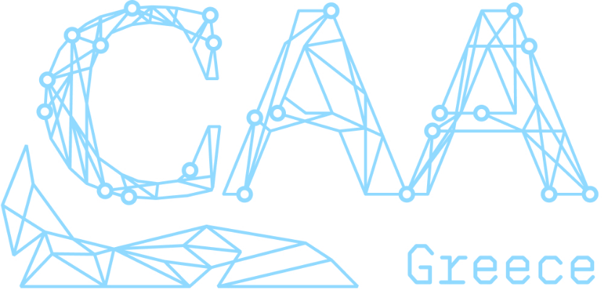

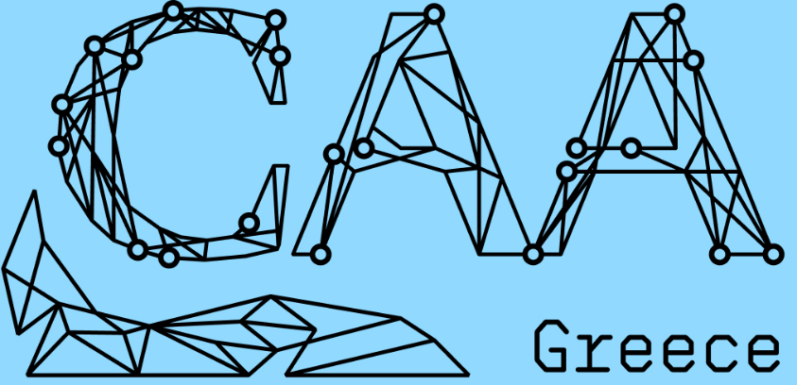

## Updates for CAA’s ESC

**Is there any information about your chapter or its activities that you would like to tell CAA’s Executive Steering Committee? This information will only be shared with the CAA’s officers and will not be made publicly available.**

We are in trouble with updating the site theme with the new logo on the CAA-Gr webpage, which is under the umbrella of the CAA international website. We are encountering technical issues, and our WEB master needs to get in touch with eh ESC in order to solve the matter.

We are willing to get aligned with the new graphic CAA standards as soon as possible.