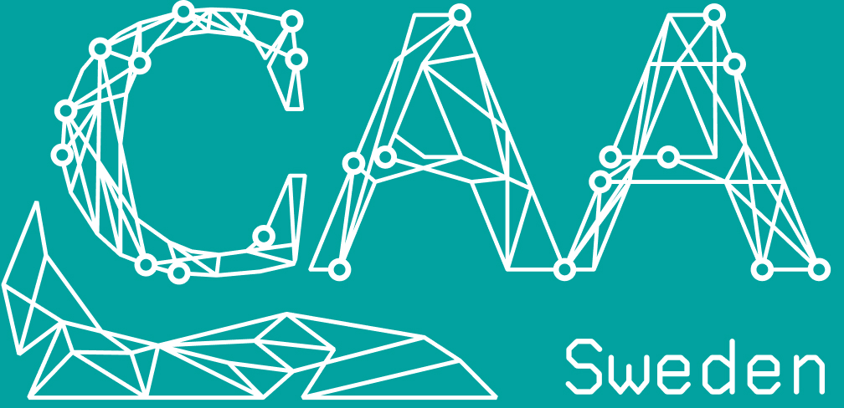

Annual Report National Chapter Sweden 2023-2024
Year 2023 The Swedish National Chapter was revived. One person from the previous Steering Committee was elected and the rest were new. We used the CAA Norway Chapter as a platform for the election.
Steering Committee:
- Chair: Jane Jansen
- Secretary: Bengt Westergaard
- Officer: Kristina Martinell
- Ancillary Officer: Marcus Smith
- Ancillary Officer: Sebastian Liahaugen
- Student officer: Alexander Röstberg
In 2024, the Swedish National Chapter held its first conference since 2017, hosted at the National History Museum in Stockholm on November 21.
The agenda was full, and about 35 people registered for the conference—more than expected. However, due to poor weather conditions and railway disruptions, only 24 participants were able to attend.
Link to program and abstracts:
The papers were held in either one of the Scandinavian languages or English.
https://docs.google.com/document/d/1F157vTA8Sal0azFw5BjOifaI3–l0YT58VAnPBUdUUw/edit?usp=sharing
During the Annual Meeting, we agreed that future conferences will be held every year, alternating between online and on-site formats. We also agreed that The Archaeologists (National Historical Museum) may pay for ‘Fika’ on onsite conferences.

